Online Appendix for

Measuring the impacts of COVID-19 on job postings in Australia using a reweighting-estimation-transformation approach

Kailing Shen, Australian National University

Bledi Taska, Burning Glass Technologies

27 August 2020

published by Australian Journal of Labour Economics, COVID-19 Special Issue 2020

Figure A1: Sample Size of Current Population Survey, Thousands

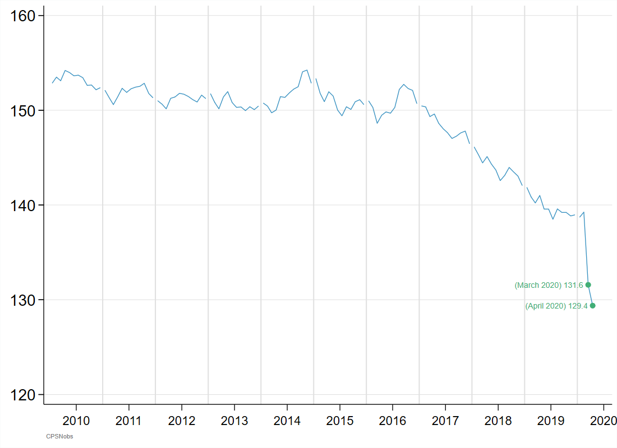

Figure A2: Sample Size of Canadian Labour Force Survey, Thousands

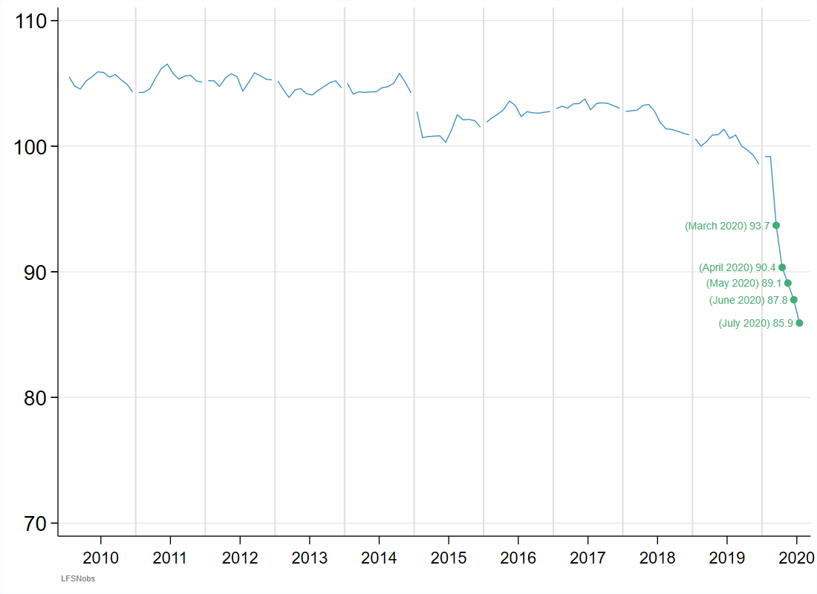

Figure A3: Percentage Changes of Raw Number of Job Postings Relative to 2019, Jan 2020 to July 2020

### (1) Temporary and Permanent Jobs

|  |
| --- |
| (a) Raw |
|  |
| (b) Composition-adjusted |
|  |

### (2) by Years of Education Required

|  |
| --- |
| (a) Raw |
|  |
| (b) Composition-adjusted |
|  |

### (3) by Years of Experience Required

|  |
| --- |
| (a) Raw |
|  |
| (b) Composition-adjusted |
|  |

### (4) by the Minimum Annual Wage Offered

|  |
| --- |
| (a) Raw |
|  |
| (b) Composition-adjusted |
|  |

### (5) by State

|  |
| --- |
| (a) Raw |
|  |
| (b) Composition-adjusted |
|  |

### (6) by Industry

|  |
| --- |
| (a) Raw |
|  |
| (b) Composition-adjusted |
|  |

### (7) by Occupation

|  |
| --- |
| (a) Raw |
|  |
| (b) Composition-adjusted |
|  |

Figure A4: Percentage Changes of Number of Job Postings Relative to 2019, Jan 2020 to July 2020: by State*Industry

Note: the numbers in the following graphs are censored within the range of [-1, 1] for ease of presentation.

### (1) New South Wales

|  |
| --- |
| (a) Raw |
|  |
| (b) Composition-adjusted |
|  |

### (2) Victoria

|  |
| --- |
| (a) Raw |
|  |
| (b) Composition-adjusted |
|  |

### (3) Queensland

|  |
| --- |
| (a) Raw |
|  |
| (b) Composition-adjusted |
|  |

### (4) Western Australia

|  |
| --- |
| (a) Raw |
|  |
| (b) Composition-adjusted |
|  |

### (5) South Australia

|  |
| --- |
| (a) Raw |
|  |
| (b) Composition-adjusted |
|  |

### (6) Australia Capital Territory

|  |
| --- |
| (a) Raw |
|  |
| (b) Composition-adjusted |
|  |

### (7) Northern Territory

|  |
| --- |
| (a) Raw |
|  |
| (b) Composition-adjusted |
|  |

### (8) Tasmania

|  |
| --- |
| (a) Raw |
|  |
| (b) Composition-adjusted |
|  |